Kaushik Mahadevan

Prof. Kim

CSIT345

23 March 2023

HW 2

A

1. 4.16

* Input and output involve reading and writing to a file. Because accessing a resource from multiple threads multiple threads leads to a concurrency problem (critical section), and because processing files is not easily parallelized, it makes the most sense to use 1 thread for each operation.
* For the CPU bound portion of the program, the work can be split among each of the 4 cores. With 1 to 1 mapping, 1 thread can be assigned to each processor core and so 4 threads should be used for this problem.

1. 4.17
   1. There are 6 unique processes created. First fork -> 2 processes total, 2nd fork -> 3 processes total, 3rd fork -> 6 processes total.
   2. One thread created for each process after the 2nd call to fork(), so two threads are created. One school of thought is that each process spins up its own thread, so there are a total of 6 threads per process + 2 newly created threads, so it could be 8, but I don’t think that’s what this question is asking for. Final answer: 2 threads

B

Below are the screenshots to all the files changed, save for header files, but those changes are implicit.

List.c – I made some changes to help the list perform like a queue. Using several of the insert methods is incredibly unsafe, but it’s pretty tough to get around that.

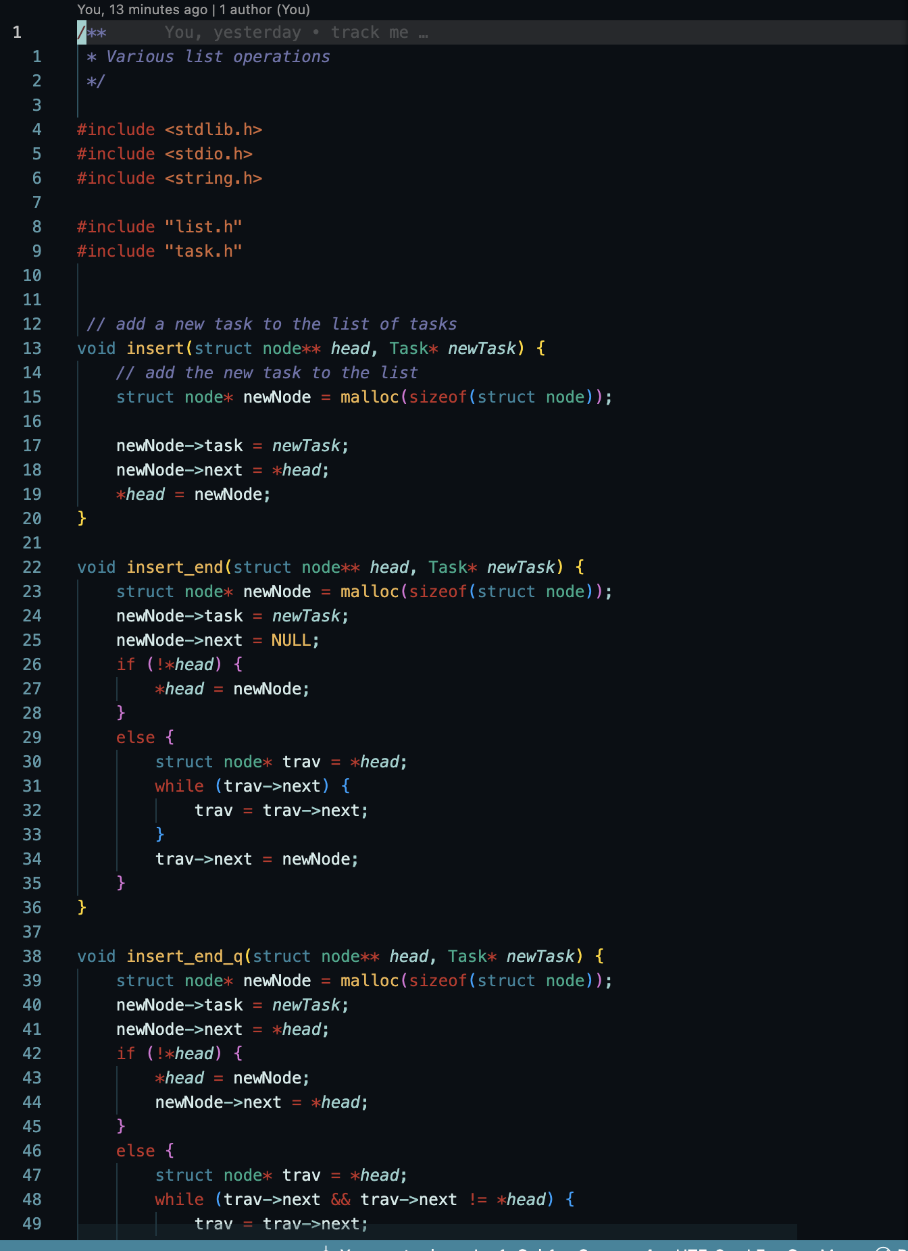

Now onto the good stuff:

FCFS

FCFS Output:

SJF:

SJF Output:

Priority:

Priority Output:

RR:

RR Output:

Priority RR:

Priority RR Output:

